**Inception network :**

In inception network we don’t have to decide which kernel size we have to use or whether we have to use max pooling or convolution, we can use this all together in inception network as shown below.

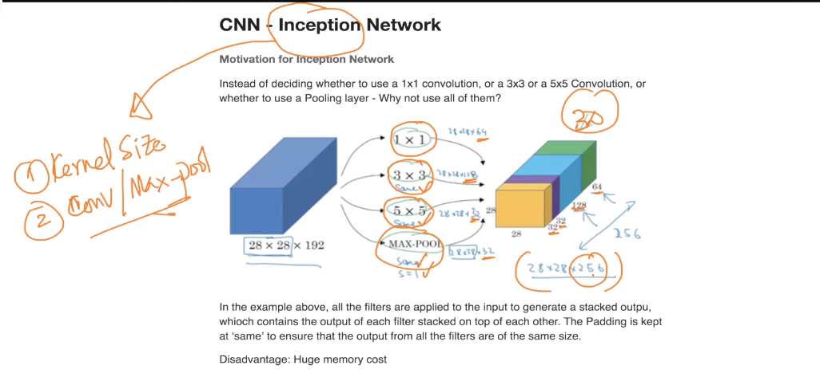

But there is one catch here of computation which is shown below.

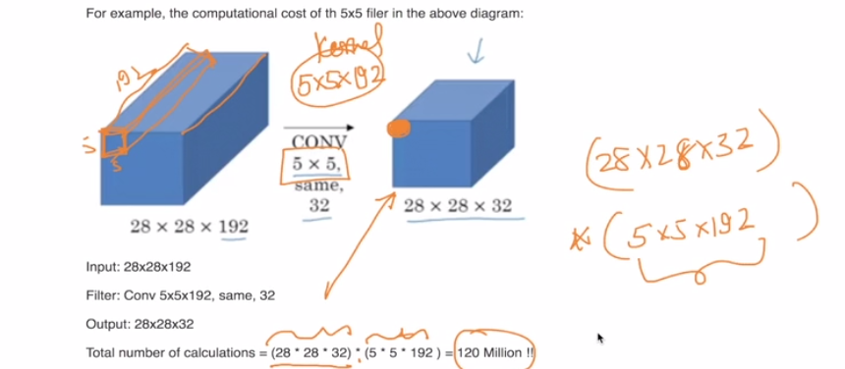

To reduce this computation we use bottleneck layer in between which reduces computation drastically.

i.e instead of using 5*5 kernel directly we us 1*1 kernel in between

and we do this for all kernels available.

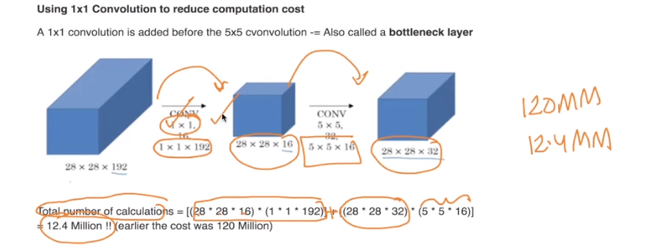

Inception module is shown below . In this module we got input as a 3d tensor and we give output as 3d tensor.

More explanation is in this blog : <http://www.ashukumar27.io/CNN-Inception-Network/>

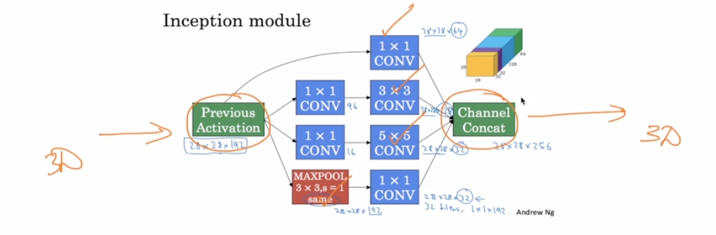

Link :

<https://towardsdatascience.com/a-simple-guide-to-the-versions-of-the-inception-network-7fc52b863202>

<https://stats.stackexchange.com/questions/274286/google-inception-modelwhy-there-is-multiple-softmax/274623#274623>

<https://mohitjain.me/2018/06/09/googlenet/>

<http://www.ashukumar27.io/CNN-Inception-Network/>

<https://github.com/keras-team/keras-applications/blob/master/keras_applications/inception_v3.py>

Comments :

